Emotional Wellness & Elevated Engagement Cohort: Week 2

September 9, 2026

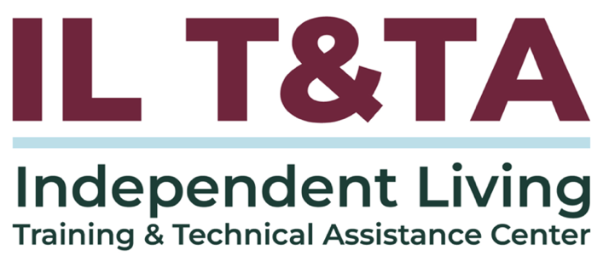

Before We Begin
ASL & Spanish Interpreters are available and labeled.
Access Closed Captioning by clicking the CC button located at the bottom of your Zoom window.
Use Zoom's Raise Hand or Chat features to ask questions.
Use the Q&A box to send us your questions at any time.
Remember to state your name and organization before speaking.
Message our IL T&TA team using the Chat feature if you have difficulties with today's call.
Please complete the survey at the end of today's training.

Cohort Learning Objectives –

Week One: Staying Grounded – Practical Safety Strategies for IL Team / Staff

Week Two: Turning Down the Heat –

De-escalation Skills for Challenging Situations
- Recognize warning signs of escalation.
- Apply de-escalation strategies that protect dignity, respect, and safety for everyone.
- Know when and how to disengage safely or seek support — honoring individual staff needs.

Week Three: Sustaining the Work – Taking Care of Yourself in Our Movement

Cohort Overview:
- Dates: September 2, 9, 16, 2026
- Flow: 60 minutes of learning + 30 minutes of peer discussion and application
- Approach: Interactive • Peer-driven • Conversational

How We’ll Learn Together:
- Be Present — Participate in the way that works for you.
- Share the Space — Make room for different voices and experiences.
- Stay Curious — We’re here to learn with and from one another.
- Honor Trust — Take the learning with you; leave personal stories in the room.
- Respect the Time — Help us keep the conversation moving
Presenters

Kristina “KK” Kapp
Executive Director

The Center for disABILITY Empowerment (CIL)


Misty Dion
Chief Executive Officer

Roads to Freedom CIL

Carrying GRACE Forward

During Week 1, we focused on what happens before we respond:

GROUND
Steady yourself and come into the moment.

REGARD
See the whole person with curiosity and positive regard.

AUTONOMY
Honor agency, choice, and self-direction.

This Week: We’ll focus on CONNECT.

Connection in the Moment
- Stay present. Notice the urge to immediately fix, correct, or take control.
- Power of peer affirmation and validation. Foundational engine of the IL Movement.
- Listen for what is being communicated. What might the person be trying to tell you?
- Stay curious. Ask rather than assume what the person needs.
- Make room for emotion. Strong emotions are valid and do not have to disappear before connection can happen.
- Keep choice in the interaction. Continue to honor autonomy.
Genuine Connection = TRUST
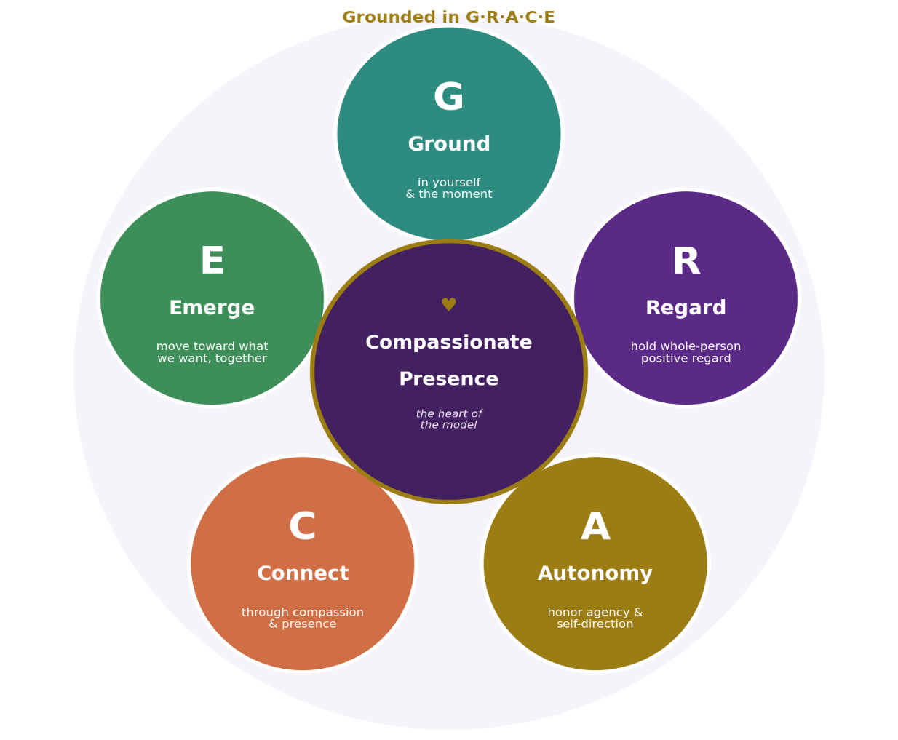

Recognize What Escalation Is — and What it is Not

Behavior is communication. What looks like “difficult” behavior may actually be distress, fear, frustration, or an unmet need.

Escalation is a signal or indicator, not automatically defiance. Stay curious and non-assumptive about what may be happening — notice what may be changing:
- Communication, tone, pace, or volume
- Movement, body language, or engagement
- Repetition or difficulty shifting focus
- Ability to process or respond to information
- The environment or people involved

Beyond The Behavior
Behavior alone doesn't tell us the whole story nor accurately reflect what a person may be trying to express or communicate.

Our role is not to control behavior but to stay present, listen, and create (or foster) the conditions for connection, choice, safety - for our peers and us.

Instead of asking: “How do I get this behavior to stop?”

Consider: “What might this person be communicating — and what safe supports could be provided in this moment?”
Catch it, Check it, Change it

Phases of Escalation Cycle
Escalation can build and shift over time. Supports needed may change with shifts.

Emotions rise (escalation) and fall (de-escalation) in phases and call for different responses; timing matters.

Communication, responses, and support will differ according to the experiences and needs of each individual.

Phases of Escalation Cycle
- Friction Point
- Intensification
- Human Hurdles or Emotional Peaks
- Restorative Wellness
- Wellness Capital

Phase 1: Friction Point
Helpful Hint: Use the word “Friction” instead of “Trigger”
Noticing signs of friction (tension) earlier allows more time to proactively respond.

What you may notice:
- Notice the body - tighter posture, faster pace, raised voice, clenched hands.
- Notice the environment / space - what changed, who is in the space, what was said.
What may be needed:
- Lower energy; calmer, steadier voice.
- Pausing; slow, controlled breaths.
- Space or distance; less room congestion.

Phase 2: Intensification
Helpful Hint: Use the word “Intensification” instead of “Escalate”
As intensity begins to rise, noticing the shift early can help us respond with connection rather than adding more pressure.
What you may notice:
- Rise in intensity / tension. Increase in physical pacing or speed of speaking.
- Repetition.
- Fixed focus.
What may be needed:
- No talking, just listening.
- Allow emotions to be expressed. Validate and affirm these.
- Avoid arguing facts. The goal isn’t to win or be right. It’s to support.
- Recognition of advocacy efforts

Phase 3: Human Hurdle or Emotional Peaks
Helpful Hint: Use the phrases “Human Hurdle” or “Emotional Peaks” instead of “Crisis”
Barriers, past experiences, trauma, and what is happening in the moment can contribute to emotional intensity. How this looks will vary from person to person.
What you may notice:
- Overwhelm or emotional flooding
- Inability to process, think logically, or remain calm.
- Rapid breathing. Defensiveness.
- Silence. Yelling. Crying.
What may be needed:
- Fewer words.
- More space, time, and patience.
- Asking what the person needs or would like.
- Focus on need for safety (if risk of self-harm is stated / apparent – don’t assume).

Phase 4: Restorative Wellness
Helpful Hint: Use the term “Restorative Wellness” instead of “Recovery”
As intensity begins to decrease, the person may need time and space before moving into reflection or next steps.
What you may notice:
- Intensity or energy starts to decrease.
- Breathing slows, voice lowers.
- Ability to process begins to return.
- Remorse / regret. Diminished hostility.
What may be needed:
- Grace and empathy.
- Stillness. Calm. Quiet.
- Gentle, reassured presence.
- ASK – “What would you like to have happen next?”
Don't rush the next step.

Phase 5: Wellness Capital
Helpful Hint: Use the term “Wellness Capital” instead of “Post-Crisis”
As intensity continues to decrease, there may be more room for reconnection, reflection, and deciding what comes next.
What you may notice:
- Decrease in physical / body tension.
- Exhaustion - physical, mental, emotional.
- Receptive to connection / reconnection, willingness to engage.
- Capacity for reflection.
What may be needed:
- Calm, steady effort to reconnect.
- Attempt to repair (relationship, trust, etc.).
- Tag-team on plan for next steps.


Let’s Pause & Reflect:
Recording has stopped.
- What's one thing that helps you keep an interaction from getting more heated?
- When you feel the "temperature" of a conversation changing, what helps you respond rather than react?

Ways to Engage:
- Raise your hand to be spotlighted to speak
- Turn on your camera if you're comfortable
- Use the chat to share insights, questions, resources, or tools
- React, reflect, or build on what others say

Match Intensity with Grounding, Don’t Control
Connection settles the nervous system. It also equalizes power dynamics and prevents top-down, punitive actions in tense situations.
- Do not overpower or suppress.
- Meet folks where they are. Share back what you hear them saying.
- Shift mindset from fixing or managing the person / problem to figuring things out together (peer-to-peer support).

Decenter Yourself, Don’t Control
Decenter yourself and how you respond.
A calm, steady environment and response help to counter stress and create a safe space for vulnerability and engagement.
Use the WHAM Relaxation Response.
- Self-reflect, be aware of reaction - breath, tone, body language, etc.
- Slow your breathing (and speaking). Take longer exhales.
- Open posture, uncross your arms.
- Respond without adding to the intensity – Your steadiness gives the other person permission to become steady, too.

Affirm & Validate, Don’t Control

Affirm and validate emotions and feelings.
- Never tell (or demand) a person to “Calm Down” – this response is dismissive and rooted in control.
- Allow emotions / feelings – Support them to recognize and name these without rushing to fix or problem solve. Just be.
- Listen and Validate – Validation and feeling heard are key to de-escalation and safety.

Recognizing and accepting what a person is experiencing without judgment, dismissal, or an immediate urge to fix them honors their dignity and humanity. This fosters Connection and builds trust.

Use Healing-Centered Practices, Don’t Control
Move away from trauma-informed to healing-centered.

Trauma-informed practices operate from a medical framework and can disregard agency and autonomy.

Healing-centered practices focus on the well-being, culture, identity, and collective support and see a person as the expert and controller of their life.
- Intensity often reflects barriers or trauma, not a personal attack.
- Body language, such as eye contact and tone, varies by culture.
- Lived experience and community wisdom are essential – be present and attune.

Prioritize Space, Don’t Control
Prioritize space rather than pressure.

Pressure and control can lead to a defensive
reaction or forced compliance, stripping people of their agency and autonomy.

- Avoid the trap of trying to force a resolution.
- Provide time, open space, and room for processing.
- Breathing room restores self-determination, autonomy, and consumer control.

When to Disengage & Seek Support

Honoring Boundaries: Safeguarding Yourself and Our Peers

Safety first: Know your limits and, if possible, the limits of the consumer / peer, and your organizational policies.

Step back warmly – take breaks: “I want to continue helping / talking; let’s take five minutes.”

Ask for help / support: For you and the consumer / peer. Reach out for peer support and tag in experts on your team; you don’t have to carry or engage in hard moments or conversations alone.

De-Escalation and Informed Choice: Contacting Law Enforcement
Centering Individual Autonomy & Safety

Consumer (individual) control, self-determination, self-direction, and systemic harm reduction MUST be prioritized and alternative supports considered before contacting or involving law enforcement.

To support and ensure the emotional wellness of our people and ourselves, we MUST limit and resist the urge to engage in automatic, systemic responses and move toward individualized, voluntary support.

What does this mean & look like in action?

De-Escalation and Informed Choice: Contacting Law Enforcement
Centering Individual Autonomy & Safety
- Center consumer (individual) control: Ask the individual directly what they may need or want, or what supports / strategies work best for them.

- Identify any immediate consumer (individual) needs: Check your bias – then determine (with the individual, if possible) if there is a specific objective or real concern occurring in the present moment without relying on assumptions.

De-Escalation and Informed Choice: Contacting Law Enforcement
Centering Individual Autonomy & Safety
- Prioritize alternative supports: Explore community-based supports / alternatives, peer networks, connections, de-escalation techniques (like Grounding), or pulling in trusted allies before involving external systems.

- Evaluate impact: Weigh how law enforcement intervention could negatively impact the individual due to their disability, trauma history, communication style / language, other identities, and intersections, resulting in real systemic harm driven by bias.

De-Escalation and Informed Choice: Contacting Law Enforcement
Centering Individual Autonomy & Safety

- Honor dignity of risk: Distinguish between a situation that involves dignity of risk (where a peer chooses to take risks or handle a situation independently) and a true, immediate safety emergency.

- Define emergency boundaries: Limit law enforcement consideration strictly to situations involving imminent, life-threatening physical danger, or when explicit legal or organizational mandates leave no alternative.

De-Escalation and Informed Choice: Contacting Law Enforcement
Centering Individual Autonomy & Safety
- Practice radical transparency: If it is determined that a mandated report or call to law enforcement must be made, inform your peer immediately - "Because of my job, the law requires me to make this call. I would like us to do this together so you can control the narrative and fight back against any forced institutionalization."
- Advocacy within the system: When submitting a mandated report, simultaneously support your peer with any critical self-advocacy or know your rights information, provide legal aid referrals, and discuss community-based alternatives so your peer is empowered.

De-Escalation and Informed Choice: Contacting Law Enforcement
Centering Individual Autonomy & Safety
- Commit to informed choices: Ensure your consumer / peer is fully informed that any final decision to contact or engage law enforcement is deliberate, documented, and actively minimizes harm, rather than serving as an automatic default.

Involving Law Enforcement & Other First Responders - Essential Communication
Share objective observations:
- Specify concerns: State the specific safety concern.
- Facts not assumptions: Separate facts from speculation, biases, assumptions, and guesses.
- Be specific regarding threats: Be exact about whether a weapon, explicit threat (including self-harm), or another immediate hazard is known.
Share communication and access needs:
- Communication: ASL, AAC, extra time, etc.
- De-escalation Pathways: Known friction points or successful approaches that reduce or ease tension and escalation.
- Actions Taken: What steps or alternatives have already been attempted.

Involving Law Enforcement & Other First Responders – Preserving Consumer Control

Center voice of consumer / peer
- Talk with, not about: Support consumer / peer with speaking directly to law enforcement or responders rather than speaking for them or about them. Be sure to share what they say they need or want, when appropriate / possible.
- Provide additional context: Communicate relevant information that may help responders understand the situation rather than only the behavior.

Scenario: Connection in Practice

Turning Down the Heat with GRACE
A conversation with an individual consumer / peer has hit an emotional peak and become heated; they’ve indicated they are frustrated and life feels out of control. Their voice is raised, and the room is very tense.

- Ground: What might you notice about the consumer / peer? What might you be feeling or experiencing? What steps might you take to help create calm?
- Regard: What might matter most to the consumer / peer right now?
- Autonomy: What choices might you offer to support agency and control?
- Connect: How might you say to validate and affirm any emotions / feelings being exhibited or expressed?

Key Takeaways
- De-escalation requires connection (and trust), not control.
- Ground yourself – calm and steady.
- Embrace emotions / feelings – validate.
- Restore agency, autonomy, and control through choice.
- Know when to disengage and seek support – for you and / or for our peers.

The Compassionate Presence GRACE Model continues in Week 3 where we’ll Emerge.

Sustaining the Work: Taking Care of Yourself in Our Movement
Wednesday - September 16, 2026
3:00 p.m. – 4:30 p.m. ET

Resources for Additional Guidance
- Emotional CPR (eCPR)
- The Compassionate Presence Model (Grounded in GRACE) – Kristina Kapp
  - Diagram
  - Pocket Card
  - Practical Application, Role-Plays & Logic Model Toolkit
- Whole Health Action Management (WHAM)
- Working Definition of Recovery - Substance Abuse and Mental Health Services Administration (SAMHSA)
- 988 Lifeline
- The Link Center - ACL

Your Experience Matters
The recording has stopped. Let’s engage in peer discussion and shared learning.
As we open the conversation:
- Take the learning with you; leave personal stories and identifying details in the room.
- Share only what you are comfortable sharing.
- Different experiences and perspectives are welcome — stay open and respectful.
Ways to Engage:
- Raise your hand to speak.
- Turn on your camera if you're comfortable.
- Use the chat to share insights, questions, resources, or tools.
- Reflect, build on what others share
- Share real challenges or successes

Evaluation
Thank you for participating in today's Cohort.

Your feedback is important and helps us plan future training.

Please use the link in the chat to share your feedback.

Evaluation Link:


How to Connect with Us!

Website: www.ILTTACenter.org
Request training and / or technical assistance (expert help for your organization): fill out a form on our website to let us know how we can help.
Call: 406-243-5300 and someone will get back to you as soon as we can.

Sign-Up for Events & Announcements:
Visit our website to sign up for updates about live training, group technical assistance, new publications, and other happenings around the Center.

IL T&TA Center Attribution

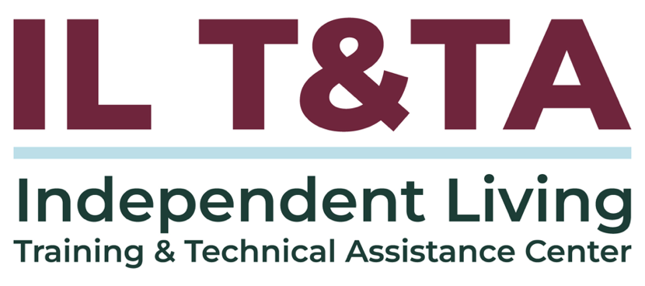

This project is on assignment through contract with the Administration on Disabilities, Administration for Community Living, Health and Human Services.

About the IL T&TA Center
The Independent Living Training and Technical Assistance Center (IL T&TA Center) is available to you through a contract with the US Department of Health and Human Services.

The IL T&TA Center provides expert training and technical assistance to CILs, SILCs, and DSEs.

The Center is operated by the University of Montana's Rural Institute for Inclusive Communities.


