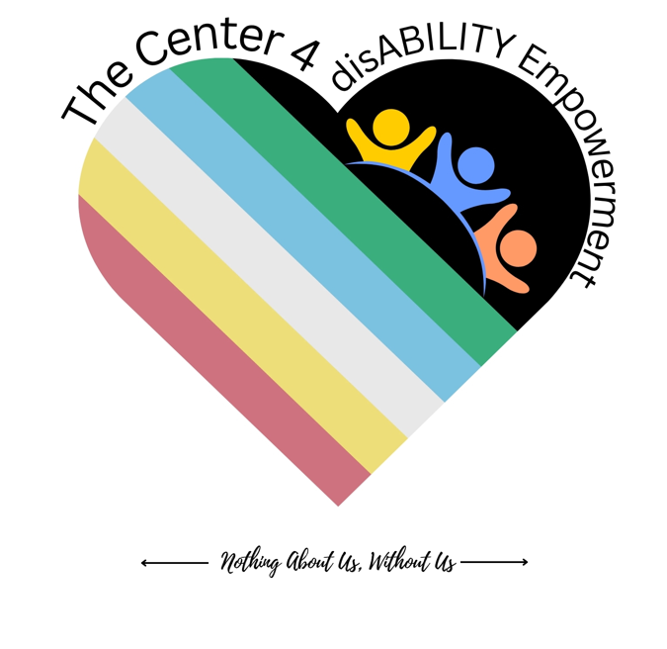 | The Compassionate Presence Model  Week 1 Pocket Card — Grounded in GRACE  The Center for disABILITY Empowerment (CIL) · Nothing About Us, Without Us
Our own Independent Living model for emotional wellness, engagement & de-escalation — created for our community, woven from evidence-based practices and grounded in IL values.
Compassionate Presence — the heart of every encounter

G | Ground — steady yourself first; presence begins in you (WHAM grounding · eCPR presence).
R | Regard — hold whole-person positive regard; get curious about worldview (peer engagement).
A | Autonomy — honor agency & self-direction; offer options, not answers (IL core values).
C | Connect — be with the feeling; compassion over control (eCPR Connecting · peer mutuality).
E | Emerge — move toward what they want, together; hope & peer support (peer engagement · eCPR Revitalizing).
Woven from: eCPR · WHAM · Peer & Recovery Engagement · Independent Living core values.
← Nothing About Us, Without Us →

Staying Grounded — Field Card
Week 1 Takeaway · GRACE in a real moment
The Center for disABILITY Empowerment (CIL) · Nothing About Us, Without Us
Before you respond, move through GRACE. Begin anywhere; return often.
G — Ground yourself first
WHAM · eCPR presence
  - Relaxation Response (WHAM): slow the breath; make the exhale longer; rest on one word or the breath.
  - Self-awareness & mindfulness: notice your body, breath, and the story you’re telling yourself.
  - Your calm is contagious — a grounded helper offers others a place to land.

R — Regard the whole person
Unconditional positive regard · peer engagement: worldview
  - Value the person without conditions; see the person, not the behavior or label.
  - Get curious about worldview: “Help me understand what this is like for you.”
  - Ask “What happened — and what matters to you?” not “What’s wrong with you?”

A — Autonomy: honor agency
IL self-direction · dignity of risk
  - The person is the expert on their life. Offer options, not answers; information, not instructions.
  - Ask permission: “Would it help if…?” Honor dignity of risk — support the choice; don’t override it.

C — Connect through presence
eCPR Connecting · peer mutuality · compassion
  - Be with the feeling before the fix; “calm down” never works — connection does.
  - Reflect what you hear; keep it mutual — side by side, not above.

E — Emerge: move toward
Peer engagement: moving toward · eCPR Revitalizing
  - “What would you like this next hour / day / life to look like?”
  - Co-create one small next step — their idea first. Warm handoff to peer support & community.

Grounding & Presence Practices
Caring for the one who cares — daily practices
The Center for disABILITY Empowerment (CIL) · Nothing About Us, Without Us
Presence is a practice, and it runs on a resource that empties. The tools that steady the people we serve are the same ones that sustain us.
The Relaxation Response (WHAM)
- Sit comfortably; let your shoulders drop.
- Breathe slowly; make the exhale a little longer than the inhale.
- Rest your attention on one word, phrase, or the breath; when the mind wanders, gently return.
- Two minutes is enough to change how you respond.
The 60-Second Reset (presence)
- Three slow breaths · feel your feet on the floor · name one thing you can see, hear, and touch.
Self-Awareness Check-In (mindfulness)
- “What am I feeling right now — and whose is it?” Name it silently so it doesn’t drive you.
- Notice early signals of depletion; asking for help is a skill, not a failure.
Whole-Health Resilience (WHAM)
- Tend sleep, movement, connection, meaning, and joy — small and repeatable beats big and rare.
You cannot pour presence from an empty cup.
← Nothing About Us, Without Us →

Compassionate Engagement — Phrase Bank
What to say · organized by GRACE movement
The Center for disABILITY Empowerment (CIL) · Nothing About Us, Without Us
Sentence stems to open connection. Use what fits the person in front of you — real beats perfect.
Ground (in yourself)
- (silently) “Feet on the floor. Slow exhale. I’ve got this moment.”
Regard (open the door)
- “It’s good to see you. How are you — really?”
- “Help me understand what this is like for you.” “What matters most to you here?”
Autonomy (share power)
- “We could do A, or B — or something you have in mind. What feels right to you?”
- “Would it be okay if I shared something that might help?”
Connect (be with)
- “That sounds really hard. I’m right here with you.”
- “We don’t have to fix anything this second.” “It makes sense you’d feel that way.”
Emerge (move toward)
- “What would you like to have happen next?”
- “What’s one small thing that would move you a little closer?”
← Nothing About Us, Without Us →

My Grounding Plan
A staying-grounded worksheet · just for you
The Center for disABILITY Empowerment (CIL) · Nothing About Us, Without Us
Staying grounded starts with you. Fill this in for yourself — it’s yours to keep.
My early signs that I’m getting dysregulated (body, mood, thoughts):

My go-to grounding practices (breath, movement, a word, a place):

People and supports I can reach for — at work and outside it:

What helps me stay present with others when it’s hard:

One small step I’ll take this week to sustain myself:

Believe It… Become It… Be It.
← Nothing About Us, Without Us →
Grounded in the Compassionate Presence Model — woven from eCPR, WHAM, peer & recovery engagement & IL core values. Emotional Wellness & Elevated Engagement cohort, Week 1.

