Insights from the Tribal Expert Peer Cohort: Advancing Indigenous Independent Living Services
September 23, 2026

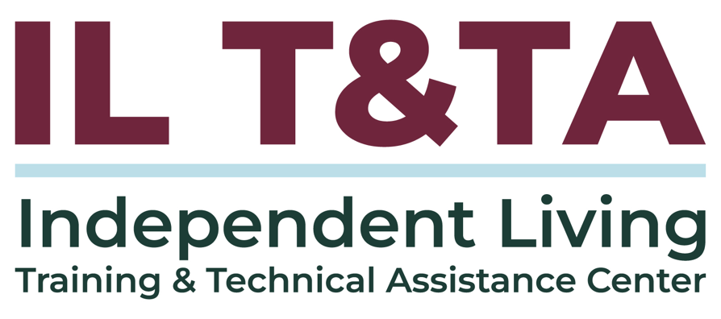

Before We Begin
ASL & Spanish Interpreters are available and labeled.
Access Closed Captioning by clicking the CC button located at the bottom of your Zoom window.
Use Zoom's Raise Hand or Chat features to ask questions.
Use the Q&A box to send us your questions at any time.
Remember to state your name and organization before speaking.
Message our IL T&TA team using the Chat feature if you have difficulties with today's call.
Please complete the survey at the end of today's training.

Today’s Agenda –

Key Takeaways:
- Participants will learn about the work the Tribal Expert Peer Cohort (TEPC).
- Participants will learn indigenous approach and perspectives to disability services.
- Participants will learn specific IL service needs and national numbers of Tribal Members served
- Participants will learn where services used to exist for indigenous people and how to address those unserved populations

Facilitators
Michael Beers – Program Outreach & Advocacy Manager, APRIL

Jules Edwards – Co-Executive Director, Autistic Women & Nonbinary Network

Panelists
Jessie Smith – Independent Living Specialist, Options Interstate Resource CIL

Eileen Tohonnie – Executive Director, Assist to Independence

Amber Sparks– Chair, Wyoming Statewide Independent Living Council

Meilani Decker– Pathways to Partnerships IL Youth Coordinator, Disability Action Center NW

A Conversation with the Tribal Expert Peer Cohort (TEPC)
- Tribal Expert Peer Cohort (TEPC) & Core Concepts

Feel free to drop questions in the chat or Q&A – we'll be sure to address them at the end!

Indigenous Perspectives On Disability
- How do Indigenous communities understand disability?

Indigenous Interdependent Living Philosophy (IILP)
- How does the Indigenous Interdependent Living Philosophy (IILP) compliment Independent Living Philosophy? Can you share about the development?

- How does the IILP help preserve cultural continuity and pass generational wisdom between older and younger community members?

Current Landscape & National Data
- What contributes to this massive gap in service delivery? What are the most pressing needs?

- Why is it a problem to treat all Native communities as a monolith when designing disability programs?

Historical Context & Attitudinal Barriers
- How does historical trauma, like boarding schools and government policies, impact Indigenous trust in outside disability agencies?

- For non-Native CIL staff who feel hesitant or anxious about making mistakes, what does genuine "cultural humility" look like in practice?

Reaching Unserved & Underserved Populations
- Experience of Urban Indians vs Rural/Tribal NDNs accessing Independent Living services?
- How can CILs identify the underserved Indigenous individuals with disabilities in their service areas? What are the biggest barriers Indigenous people have to accessing IL services?
- If you could give one piece of advice to every attendee on this webinar to take back to their organization tomorrow, what would it be?

Resources for Additional Guidance
- Services for Native Americans (OAA)
- Aging, Independence, and Disability (AGID) Data Portal
- Association of Programs for Rural Independent Living

Learn & Share: Your Experience Matters
Recording has stopped – now it’s time to share.

Ways to Engage:
- Raise your hand to be spotlighted to speak
- Turn on your camera if you're comfortable
- Use the chat to share insights, questions, resources, or tools
- React, reflect, or build on what others say
- Share real challenges or successes from your CIL
Let’s turn ideas into action — your voice is the most valuable part of this session.

Evaluation
Thank you for participating in today's Learn and Share.

Your feedback is important and helps us plan future training.
Please use the link in the chat to share your feedback.
Evaluation Link:
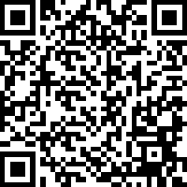

How to Connect with Us!

Website: https://tinyurl.com/ILTTACenter
Request training and / or technical assistance (expert help for your organization): fill out a form on our website to let us know how we can help.
Call: 406-243-5300 and someone will get back to you as soon as we can.
Sign-Up for Events & Announcements:
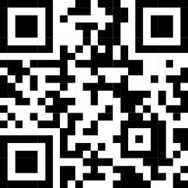
Visit our website to sign up for updates about live training, group technical assistance, new publications, and other happenings around the Center.

IL T&TA Center Attribution

This project is on assignment through contract with the Administration on Disabilities, Administration for Community Living, Health and Human Services.

About the IL T& TA Center
The Independent Living Training and Technical Assistance Center (IL T&TA Center) is available to you through a contract with the US Department of Health and Human Services.
The IL T&TA Center provides expert training and technical assistance to CILs, SILCs, and DSEs.
The Center is operated by the University of Montana's Rural Institute for Inclusive Communities.
