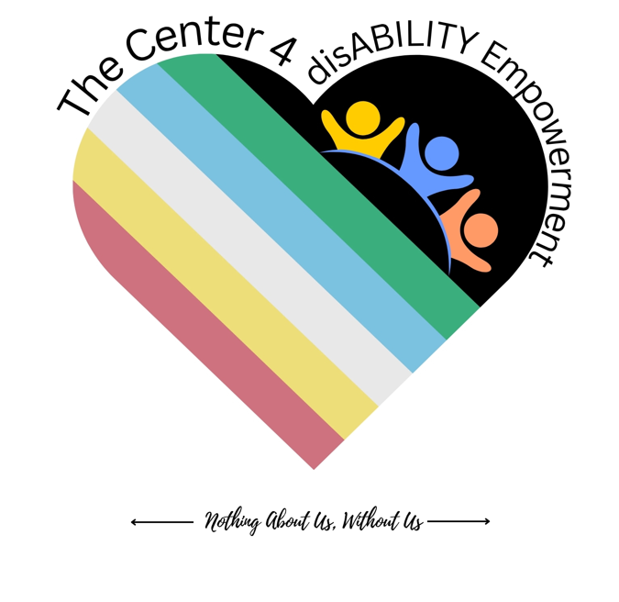 | The Compassionate Presence Model  Week 3 Pocket Card — Grounded in GRACE  The Center for disABILITY Empowerment (CIL) · Nothing About Us, Without Us
Our own IL model for emotional wellness, engagement & de-escalation — created for our community. This week we lean into Emerge.
Compassionate Presence — the heart of every encounter

G | Ground — steady yourself first; presence begins in you (WHAM).
R | Regard — hold whole-person positive regard; get curious about worldview (peer engagement).
A | Autonomy — honor agency & self-direction; offer options, not answers (IL core values).
C | Connect — be with the feeling; compassion over control (evidence-based practice · lived experience).
E | Emerge — move toward what we want, together; hope & peer support.
Woven from: WHAM · evidence-based practice · lived-experience & community wisdom · IL core values.
← Nothing About Us, Without Us →

Sustaining the Work — Field Card
Week 3 Takeaway · GRACE turned toward you
The Center for disABILITY Empowerment (CIL) · Nothing About Us, Without Us
You can’t pour presence from an empty cup. Sustaining yourself IS the work.
G — Ground (daily)
WHAM self-care
- Relaxation Response; a 60-second reset; small, repeatable practices beat big, rare ones.
- Notice early signs of depletion — name them before they run you.

R — Regard yourself
self-compassion
- Value yourself without conditions — you’re a human being, not a machine.
- Speak to yourself the way you’d speak to a peer you respect.

A — Autonomy: boundaries
IL self-direction for staff
- Say “no,” or “not like this,” warmly and clearly. You get to author your limits.
- Protect time and energy so you can keep showing up.

C — Connect
peer support & community
- Peer support is for staff, too — mutual, lived-experience-based. You’re not alone.
- A simple circle: check in, share one challenge, reflect together, close.

E — Emerge
purpose & hope
- Reconnect with why you came to this work; move toward your hopes, not only away from what’s hard.
- Choose one small step toward your own wellness this week.

Whole-Health & Grounding Practices
WHAM · caring for the one who cares
The Center for disABILITY Empowerment (CIL) · Nothing About Us, Without Us
The Relaxation Response (WHAM)
- Sit comfortably; slow the breath; longer exhale; rest on one word; return gently when the mind wanders.
Whole-Health Factors
- Stress management, healthy eating, physical activity, restful sleep, service to others, support network, optimism, spiritual practice, a sense of meaning, and enjoyment. Tend ONE this week.
The 60-Second Reset
- Three slow breaths · feel your feet · name one thing you can see, hear, and touch.
Self-Awareness
- “What am I feeling right now — and whose is it?” Asking for help is a skill, not a failure.
You cannot pour presence from an empty cup.
← Nothing About Us, Without Us →

Boundaries & Self-Advocacy — Scripts
Nothing About Us, Without Us — includes you
The Center for disABILITY Empowerment (CIL) · Nothing About Us, Without Us
Boundaries are how we sustain compassion. Say them warmly and clearly.
Saying no
- “I can’t take that on right now.” “That doesn’t work for me today.”
“Not like this”
- “I want to help — here’s what I can do instead.”
Asking for support
- “I need help with…” “Can we share this load?”
Self-advocacy
- “Here’s what I need from the team to keep doing this well.”
- “Nothing About Us, Without Us — that includes me.”
← Nothing About Us, Without Us →

My Sustainability Plan
A staying-well worksheet · just for you
The Center for disABILITY Empowerment (CIL) · Nothing About Us, Without Us
Yours to keep. Sustaining yourself is part of the work.
My early signs of burnout or depletion (body, mood, thoughts):

My whole-health practices — the one I’ll tend this week:

Boundaries I’ll protect — at work and outside it:

My peer and support people I can reach for:

One small step toward my own wellness this week:

Believe It… Become It… Be It.
Grounded in the Compassionate Presence Model — WHAM, evidence-based practice, lived-experience wisdom & IL core values. Cohort Week 3.

