Analyzing and Using Input Gathered for SPIL Development
October 20, 2026
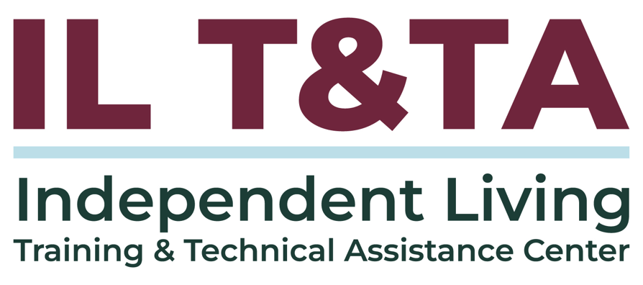

Before We Begin
- Language Access: ASL and Spanish interpreters are available and labeled.
- Live Captions (CART): Available in English and Spanish. Select Zoom's CC button for English or use the caption links in Chat.
- Need Assistance? Message the IL T&TA team in Chat if you need support.
- Questions & Engagement: We welcome your questions, thoughts, and insights anytime through Q&A or Chat. We'll explore them together during the peer discussion.
- Before You Go: Please complete our brief training evaluation.

Today’s Agenda

Key Takeaways:
- Learn how to turn public input into real next steps during SPIL development: goals, objectives and more.

Overall Goal:
- Let's learn with and from each other!

Presenter
Jeremy Morris
Executive Director
Ohio Statewide Independent Living Council (OSILC)
jmorris@ohiosilc.org
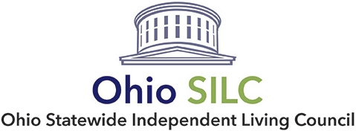

Facilitator
Brooke Wilson
Chair- NASILC (National Association of State Independent Living Councils)
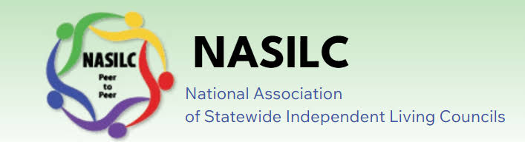

Public Input: Where the State Plan for Independent Living (SPIL) Begins
The federal regulations on the SPIL and the SILC Indicators lay out the following requirements the SILC must follow to get public input on the development of the SPIL.

Public Input Is the First Step: You must receive public input from individuals with disabilities and other stakeholders throughout the State before the SPIL can be developed.

Introduction to Data and Public Input
- Public input isn’t just about saying you did it; it should influence your plan.
- The challenge is usually analyzing and assessing.
- Deciding on information like:
  - What does this mean?
  - What should impact statewide priorities?
- What can the network actually do?

You Collected Input – Now What?
- SPIL Development can collect a lot of input. Surveys, listening sessions, public meetings, consumer stories, CIL feedback, needs assessments, data reviews, and collection.
- You can’t immediately look at the info and go from “people say there is an issue with transportation” to “we need a goal to fix transportation”

Step 1: Turn Comments into Themes
- 100 people may say transportation is an issue.
- Are you able to see themes in the responses?
  - Limited access
  - Rural availability
  - Cross-county travel
  - Affordability
  - Accessibility
  - Reliability
- You must organize your input into what you heard before deciding what it means for the network.

Step 2: Ask What The Themes Tell You
- How widespread is this?
- Who is experiencing it most?
- Where is it happening?
- What is causing the barriers?
- How does it risk people’s ability to live in the community?
- Is there other information that supports what we heard?
- Example:
  - Theme: People have a difficult time accessing accessible transportation
  - Finding: People in rural areas have fewer accessible transpiration options.

Step 3: Look For Other Support
What other information or data could help you understand the issue, support the feedback, or provide more details?
- Look at data from:
  - PPRs (Performance Progress Reports)
  - Other state plans
  - Other research
  - Partner organizations
- This can confirm information or highlight gaps that others' aren’t seeing.

Step 4: Prioritize
We can’t realistically address every issue from public input.
3 yrs often can’t fix every problem.
Look into the issues and ask:
- How does this relate to the Purpose Statement of Title VII?
- How can the Network make a difference?
- What can [realistically] be done in 3 yrs?
- How will this impact individuals?

Step 5: Turn Priorities Into Goals
The community identifies needs; the SPIL identifies how & what the network can concentrate and focus on.
- After you hear about the problems, review it with other information, and understand how you can work on it…
- Determine what the change you want to make is.
- Your goals focus on the changes you can and want to make with the SPIL.
- This is where the public input helps decide what future you want to see.

Step 6: Building Objectives
- After you know the future you want to see, you can look at the specific things that need to happen to make that real.
- This is where you can build your objectives.
- What specifically has to happen for that change we want to occur

Step 7: Decide How To Know You Make Changes
- Look back at the input you received after you have your goals and objectives.
- Can you see how your work is connected to what people told you?
- How can you use the input and that data you reviewed to see if you are making changes?

Resources for Additional Guidance
Community Assessment for Accessible Rural Events Toolkit | University of Montana

"Outcome Measurement Toolkit: A Resource for Centers for Independent Li" by University of Montana Rural Institute

Your Experience Matters
Recording has stopped – now connect, share, and learn together!
Ways to Engage:
- Join In: Raise your hand to speak, and introduce yourself and your organization.
- Participate Your Way: Turn on your camera if comfortable, or share questions, ideas, and resources in Chat.
- Keep It Accessible: Speak one at a time and allow time for interpretation and captions.
- Learn Together: Share experiences, celebrate successes, explore challenges, and build on each other's ideas.
Your experiences matter.
Your ideas make a difference.
Together, let's turn ideas into action!

Evaluation
Thank you for participating in today's Learn and Share.

Your feedback is important and helps us plan future training.
Please use the link in the chat to share your feedback.
Evaluation Link:
QR Code


How to Connect with Us!
Website: https://tinyurl.com/ILTTACenter
Request training and / or technical assistance (expert help for your organization): fill out a form on our website to let us know how we can help.
Call: 406-243-5300 and someone will get back to you as soon as we can.
Sign-Up for Events & Announcements:

Visit our website to sign up for updates about live training, group technical assistance, new publications, and other happenings around the Center.

IL T&TA Center Attribution

This project is on assignment through contract with the Administration on Disabilities, Administration for Community Living, Health and Human Services.

About the IL T& TA Center
The Independent Living Training and Technical Assistance Center (IL T&TA Center) is available to you through a contract with the US Department of Health and Human Services.
The IL T&TA Center provides expert training and technical assistance to CILs, SILCs, and DSEs.
The Center is operated by the University of Montana's Rural Institute for Inclusive Communities.
